TASK 1:

INCLUDE Irvine32.inc

.data
arr1 word 11,12,13,14,15,16,17,18,19,20
newarr word 10 dup (?)
.code
main PROC
mov eax, 0
mov ecx, lengthof arr1

mov esi, offset arr1

; copying values to stack
l1:
push [esi]
add esi, 2
loop l1

; popping values and inserting in new array
mov esi, offset newarr
mov ecx, lengthof arr1
l2:
pop eax
mov [esi], eax
add esi, 2
loop l2

;---printing values---
mov ecx, lengthof newarr
mov esi, offset newarr
l3:
movzx eax, WORD PTR [esi]
call writedec
call crlf
add esi, 2
loop l3

exit
main ENDP
END main
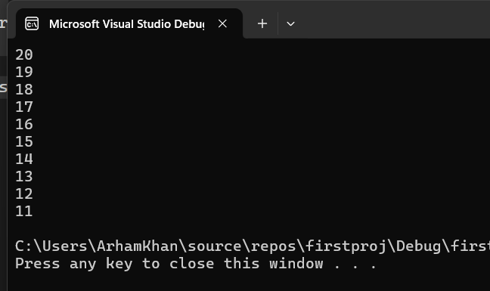
TASK 2:
INCLUDE Irvine32.inc

.data
additionSum dword ?
prompt byte "Sum of three Integers: ",0
.code
main PROC
mov eax, 0
mov ebx, 0
push 7
push 8
push 9

mov ecx, 3

l1:
pop ebx
add eax, ebx
loop l1

mov edx, offset prompt
call writestring
call crlf

mov additionSum, eax
call writedec

exit
main ENDP
END main
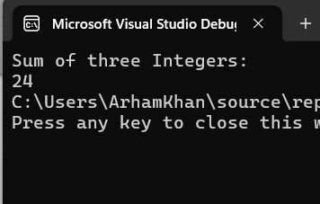
TASK 3:

INCLUDE Irvine32.inc

int_count = 5
.data
arr1 dword 10,20,30,40,50
arr2 dword 100,200,300,400,500
sum1 dword 0
sum2 dword 0
totalSum dword ?
prompt byte "Sum of both arrays: ", 0

.code
main PROC
mov eax, 0
call arrsum1
call arrsum2
call TOTAL

mov edx, offset prompt
call writestring
call crlf

mov eax, totalSum
call WriteInt

exit
main ENDP

arrsum1 PROC
mov eax, 0
mov ecx, int_count
mov esi, offset arr1
l1:
add eax, [esi]
add esi, 4
loop l1
mov sum1, eax
ret
arrsum1 ENDP

arrsum2 PROC
mov eax, 0
mov ecx, int_count
mov esi, offset arr2
l1:
add eax, [esi]
add esi, 4
loop l1
mov sum2, eax
ret
arrsum2 ENDP

TOTAL PROC
mov eax, sum1
add eax, sum2
mov totalSum, eax
ret
TOTAL ENDP

END main

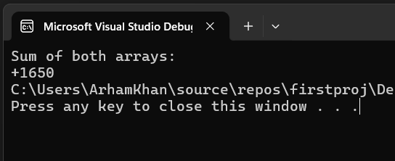
TASK 4:

INCLUDE Irvine32.inc

.data
prompt byte "Write the integer n for sum: ", 0
prompt2 byte "Sum of integers 1 to n: ", 0
userInput dword ?

.code
main PROC
mov eax, 0
call printSum

exit
main ENDP

printSum PROC uses eax
mov edx, offset prompt
call writestring
call crlf
call readdec
mov userInput, eax

mov ecx, userInput
mov eax, 1
l1:
add eax, 1
loop l1

mov edx, offset prompt2
call writestring
call crlf
call writedec
ret
printSum ENDP

END main

OUTPUT:

